**Dharmam’s(**dkp150130**) part:**

* Since the onset of this project I have stuck to the R code for this challenge.
* While R coding was a bit complicated then the GUI of rattle, however, it provided an excellent learning experience.
* The Code and data amputation techniques are in the submitted zip folder and mentioned in report.
* I have also been following the Kaggle forum to get insights on this problem on regular basis.
* Helped in the selecting and writing contents of both the report.

**Code –**

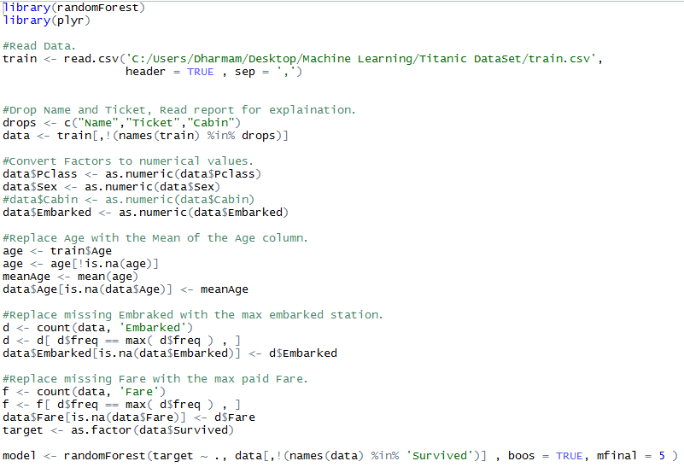

**Kaggle Submission –**

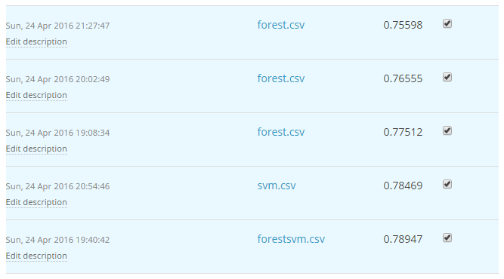

**Darshan's(**dkp150130**) part:**

* Apart from the things like kicking off the project in initial phase including data imputation, I have used 'rattle' library in R which is a graphical interface used to build model using various clustering and classifiers.
* Apart from this, rattle library is a great source to learn data imputation.
* Rather than involving more on coding, I was more involved with imputing and trying all possible clustering and strong classifiers performance analysis with the help of rattle library.
* I have also, formatted and customized both the reports according to given requirements.

To get this interface:

install.packages(rattle)

library(rattle)

rattle()

Please find below screenshots of the graphical interface of rattle:

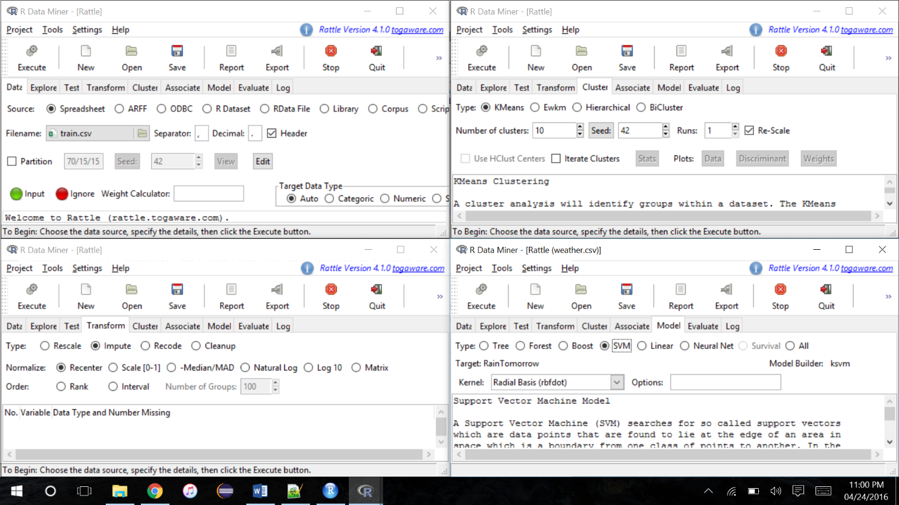

Accuracy posted on Kaggle:

